# Array:

* Storing Multiple value in single variable.
* Non-Primitive datatype

# Features:

* Its supports similar datatype [homogeneous elements]
* Index based
* int a[]={1,2,3,4,5} Length=5 Index=5-1=4
* Index starts from 0 to n-1 🡪 where n=length

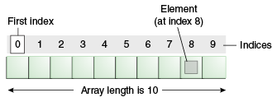

**Instantiation of an Array in Java**

Datatype arrayRefVar[]=**new** datatype[size];

Datatype arrayRefVar[]=**{**12,13,14};

int a[i] =new int[500];

a[0]=12;

a[1]=13;

int a[i] ={12,54,87};

50-use

450—memory wastage

# Types of Array in java

# There are two types of arrays.

* Single Dimensional Array 🡪 int a[]=new int[3];
* Multidimensional Array🡪 int b[][] = {{1,2,3},{2,3},{3}};

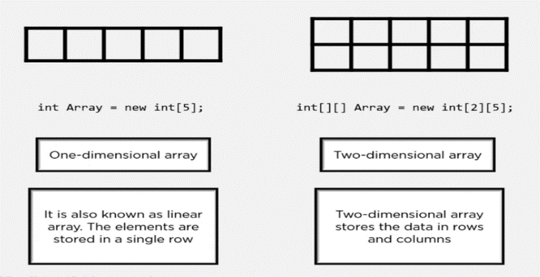

# Disadvantages:

* it will support similar datatype
* it has fixed length
* it is high memory wastage

But it can be overcome by collection.

Note: If we not initialize the value the default value of the datatype will be printed.

If we override, the value of last value will be printed.

# Scanner:

* It is a Class
* Scanner class present in java.util.Scanner package
* To get the input from the user in Run time.

Syntax:

Scanner refName=new Scanner(System.in);

Where

Scanner🡪 Class

System.in🡪 To take input from console

System.out🡪to print the console

Scanner Methods:

**next();**

Accept only one value.

After space it wont accept.

**nextline();**

Accepts more than one value

After space it will accept

**nextint();**

It accept a integer values like whole numbers.

**nextfloat();**

It accept a decimal values